**Alternate Test Cases**

Use Case 1: Sign Up

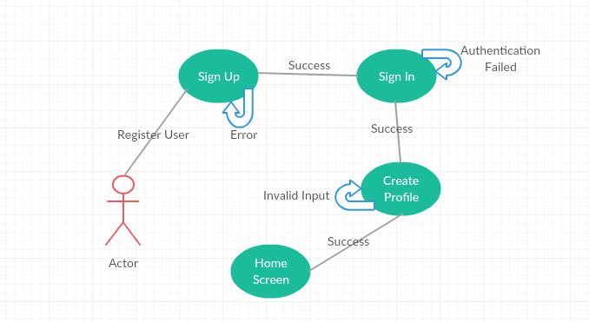

Use Case 2: Sign In

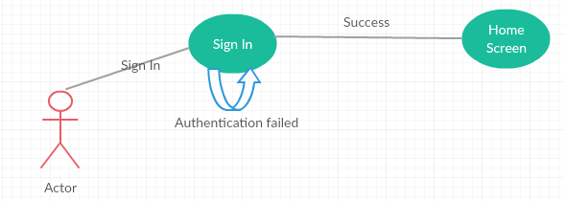

Use Case 3: Edit Profile

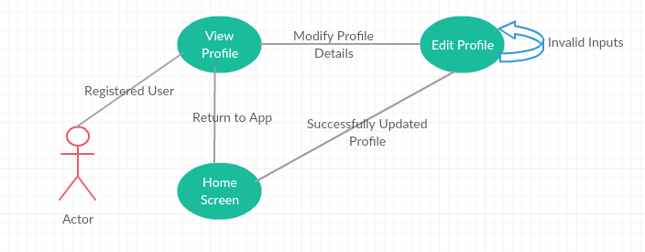

Use Case 4: Search travel buddies based on Destination

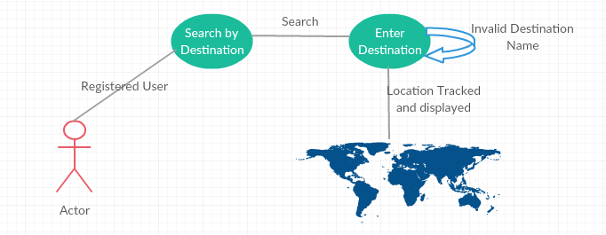

Use Case 5: Send Audio Message to contact Travel Buddy

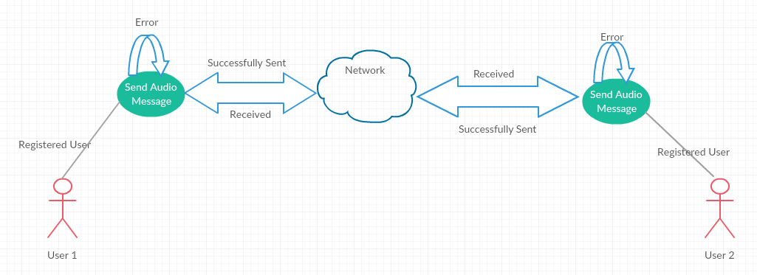

Use Case 7: Send Video message to contact Travel buddy

